1. Launch your preferred browser and navigate to:

<https://azureforeducation.microsoft.com/devtools>

1. Click **Sign In** to be re-directed to the Microsoft sign in page.



1. Enter your UPN Logon [username@humber.ca](mailto:username@humber.ca) and **Next** to be redirected to the Humber login page. You will immediately be logged into Azure Dev Tools.

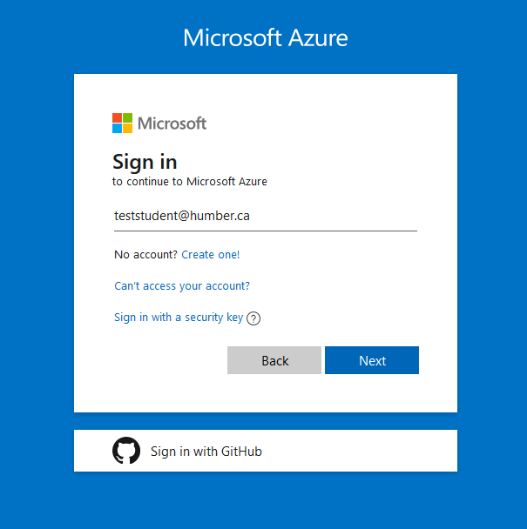 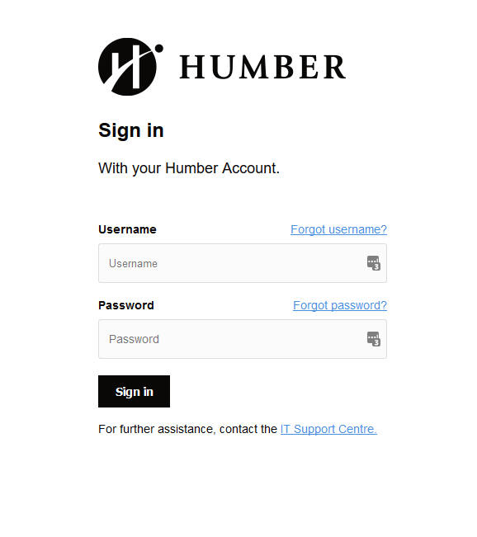

1. Under **Learning resources**, click on **Software** to access the subscription.

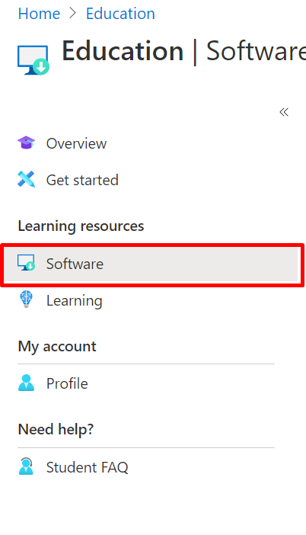

1. Please insure that your existing Office Suite matches the **System Type** (**32/64 bit**) and **Version** of the program you wish to download.

For example: If the current version of Office Suite you have installed is Office365, it will **NOT** be compatible with Visio or Project 2016 or 2019. In that case, you will need to uninstall Office365 Office Suite and install Microsoft Office 2016 or 2019.

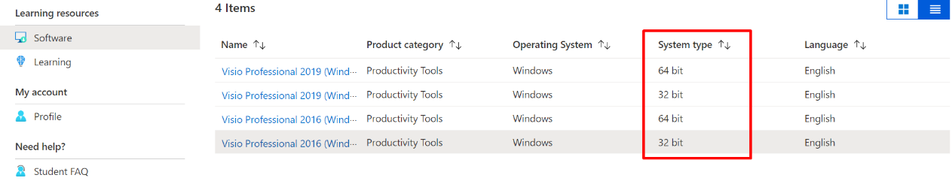

**To check your existing Office Suite system type**, please follow these instructions

1. Open up an Office Suite application such as Word
2. Go to **File -> Account -> About Word**

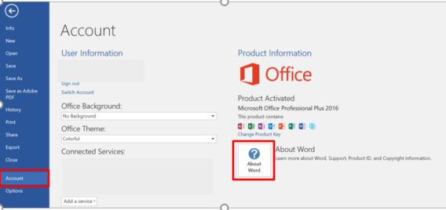

1. Here you will see the whether the Office Suite currently installed on your machine is 32-bit or 64-bit and whether you are using Office 2016, 2019 or Office365.



1. Once you have verified your current Office Suite version and system type, return to [Azure Dev Tools](https://azureforeducation.microsoft.com/devtools) and click on the software you would like to download and Click **Generate URL. Copy the URL onto another browser window or tab to start the download.**

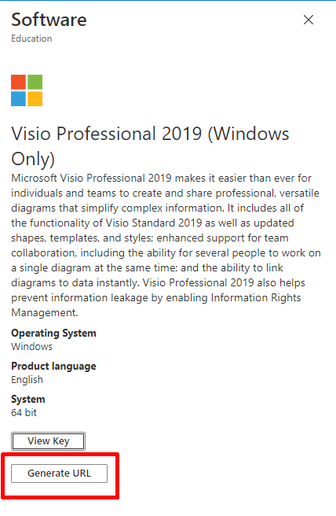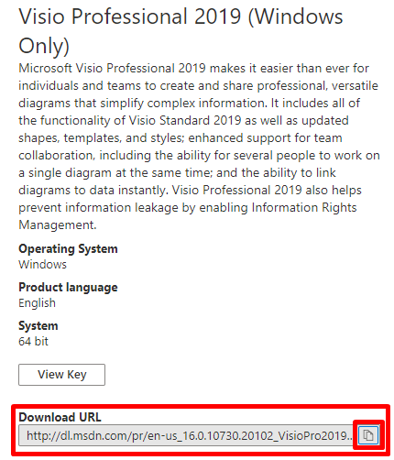

1. Please also click the "**View Key**" box on the right. Copy the serial number to a text file in case you cannot open the page again.

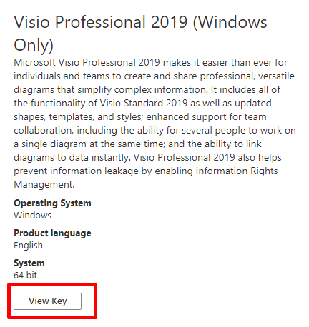

1. The download file downloads as an ISO. Double click the ISO file and then double click on the setup.exe file to run it. Once the installation completes, the window will close automatically.
2. Go to the start menu and then search for the downloaded program and launch the program. The program may prompt you to enter the key that you copied from Step 7 to activate it. Please paste the key if prompted.

***If you require further assistance, please contact the I.T. Support Centre at either 416-675-6622 X8888, humber.ca/techtalk, or***[***SupportCentre@humber.ca***](mailto:SupportCentre@humber.ca)***.***